Javalin

- Javalin is a web framework for creating web servers in Java (or Kotlin)
  - This is a classic way to process HTTP requests in our back end (server) and return an HTTP response to the front end (client).
  - In other words, Javalin lets us send and receive data from our Java apps through HTTP. This is an integral process in full stack apps.
- Javalin is event driven - Each HTTP request to your server is an “event”, which triggers a certain HTTP Handler in response.

I’m gonna be so real with you guys – no enterprise-scale app uses Javalin for these days. Most people fulfill its use case with Spring (a huge yet beautiful framework we’ll see next). But it’s quick and easy to use, and it DOES work fine. I don’t mind it as our first look at integrating HTTP capabilities into a Java app. Also it’s required for the project so I guess you have no choice anyway.

HTTP Handlers

- Javalin uses HTTP Handlers to take in HTTP Requests and return HTTP Responses. The main type of handler we’ll use is the endpoint handler.

Endpoint Handlers - We’ll write a bunch of these in main(). A Handler invokes its functionality when an incoming HTTP request matches its HTTP verb + URL endpoint

Here’s a root-level endpoint mapping that allows 2 GET requests
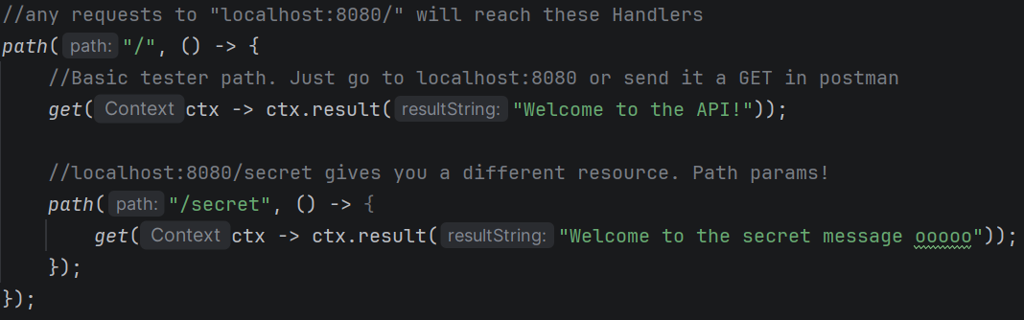
-First GET Request: Just a super-basic endpoint that returns a String when a request is sent to localhost:8080/
-Second GET Request: Another basic endpoint that returns a different String when a request is sent to localhost:8080/secret

Here’s a more realistic endpoint mapping to /users (so NOT root-level)
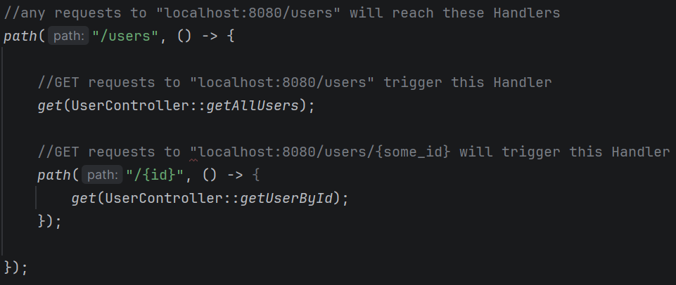
-GET request to localhost:8080/users – Get All Users logic which invokes a method in the UserController.
-GET request to localhost:8080/users/{something} – Get User By Id logic which invokes a different method in the UserController, getting whatever User’s ID corresponds to the variable that’s passed in
-(If a non-String or nonexistent ID is sent, you need to error handle for that)

*What’s that :: syntax? That’s “method reference syntax”, basically a shorthand way to invoke a method. We could have used userController.methodName() instead.

- Within our handlers, we rely on the Context (ctx) object to:

  - Take in HTTP Request data
    - store incoming HTTP Request data with ctx.body()
    - store incoming HTTP Request data AND convert it from JSON to Java with ctx.bodyAsClass()
ctx.bodyAsClass()

  - Send and configure HTTP Responses
    - return non-JSON data in an HTTP response with ctx.result()
    - return JSON data in an HTTP response with ctx.json()
    - set HTTP response status codes with ctx.status()
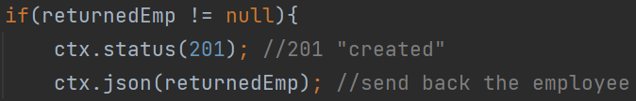 ctx.status() and ctx.json()
- https://javalin.io/documentation#context <--- all ctx methods for reference

- Error and Exception handling in Javelin is very straightforward.
  - Just configure it in your Javalin startup logic

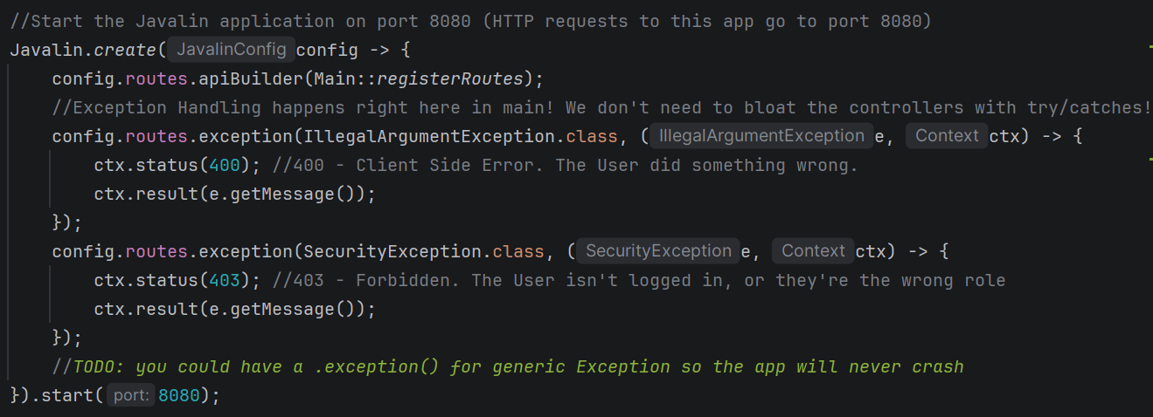
This is an entire Javalin.create block. We abstracted the routing logic into a method called registerRoutes, which we COULD have done for the two Exception handlers you see here.

Also note the .start() method at the end which starts the server on the specified port (8080 here)

Tying this all together

- Problem:
  - You have an internet full of web servers written in a bunch of different programming languages. You want to make sure that they can all communicate with each other. BUT...
  - Every language has different data types. Some languages have a single “number” type. Other languages have a bunch of types representing numbers.

- Solution:
  - We need a universal format that any programming language can understand, so they can communicate.
  - This is where JSON comes in! Our front end and back end will be sending data back and forth using JSON
  - Then we use Javalin to take in HTTP requests, and parse JSON using the HTTP handlers.
    - HTTP Requests will then typically contain JSON that’s been converted FROM Java objects

